Département de Génie Informatique et Communication

Department of Information and Communication Engineering

Topic : TP10

Subject : Internet Programming

Teacher : Mr. Hok Tin

Name : YORNG TONGHY

ID : e20191313

Group : I4-GIC-C

Year : 2022-2023

# Table of Contents

- Table of Contents 2

• GitHub link 3

Exercise1: Integrate the previous authentication APIs with VueJS. 3

• Register 4

• Register account successfully 4

• Data in MongoDB after register it’s load new data in database. 5

• Home-Page 5

Exercise2: Continue implementing the authentication and user APIs 5

• Result of Ex02: 6

• login user and get token: 6

• Register 6

• Register already existed. 7

• When No Token 7

• Invalid Token 8

• Access by username via correct token 8

• When update user with invalid email format: 9

• Update user Successful: 9

• When update password successfully: 10

• Delete User 10

• Data before delete: 10

• When delete user does not exist in database. 11

• Delete user successfully. 11

* GitHub link: <https://github.com/yorng-tonghy/TP08_IP-TP09_IP/tree/TP10>

# Exercise1: Integrate the previous authentication APIs with VueJS.

• Result of Exercise1:

• Login

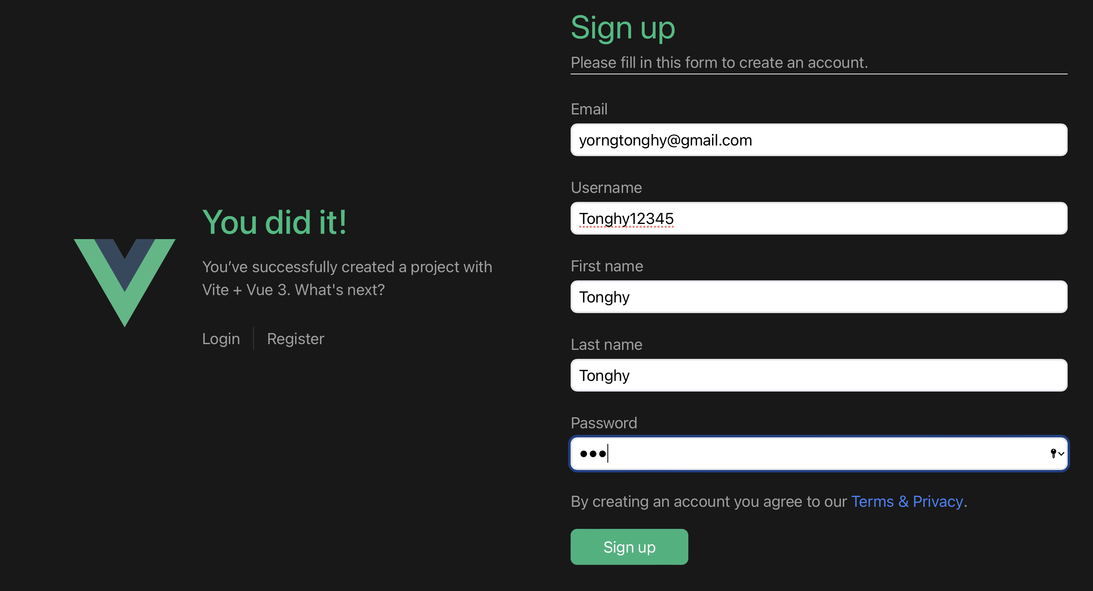

## Register

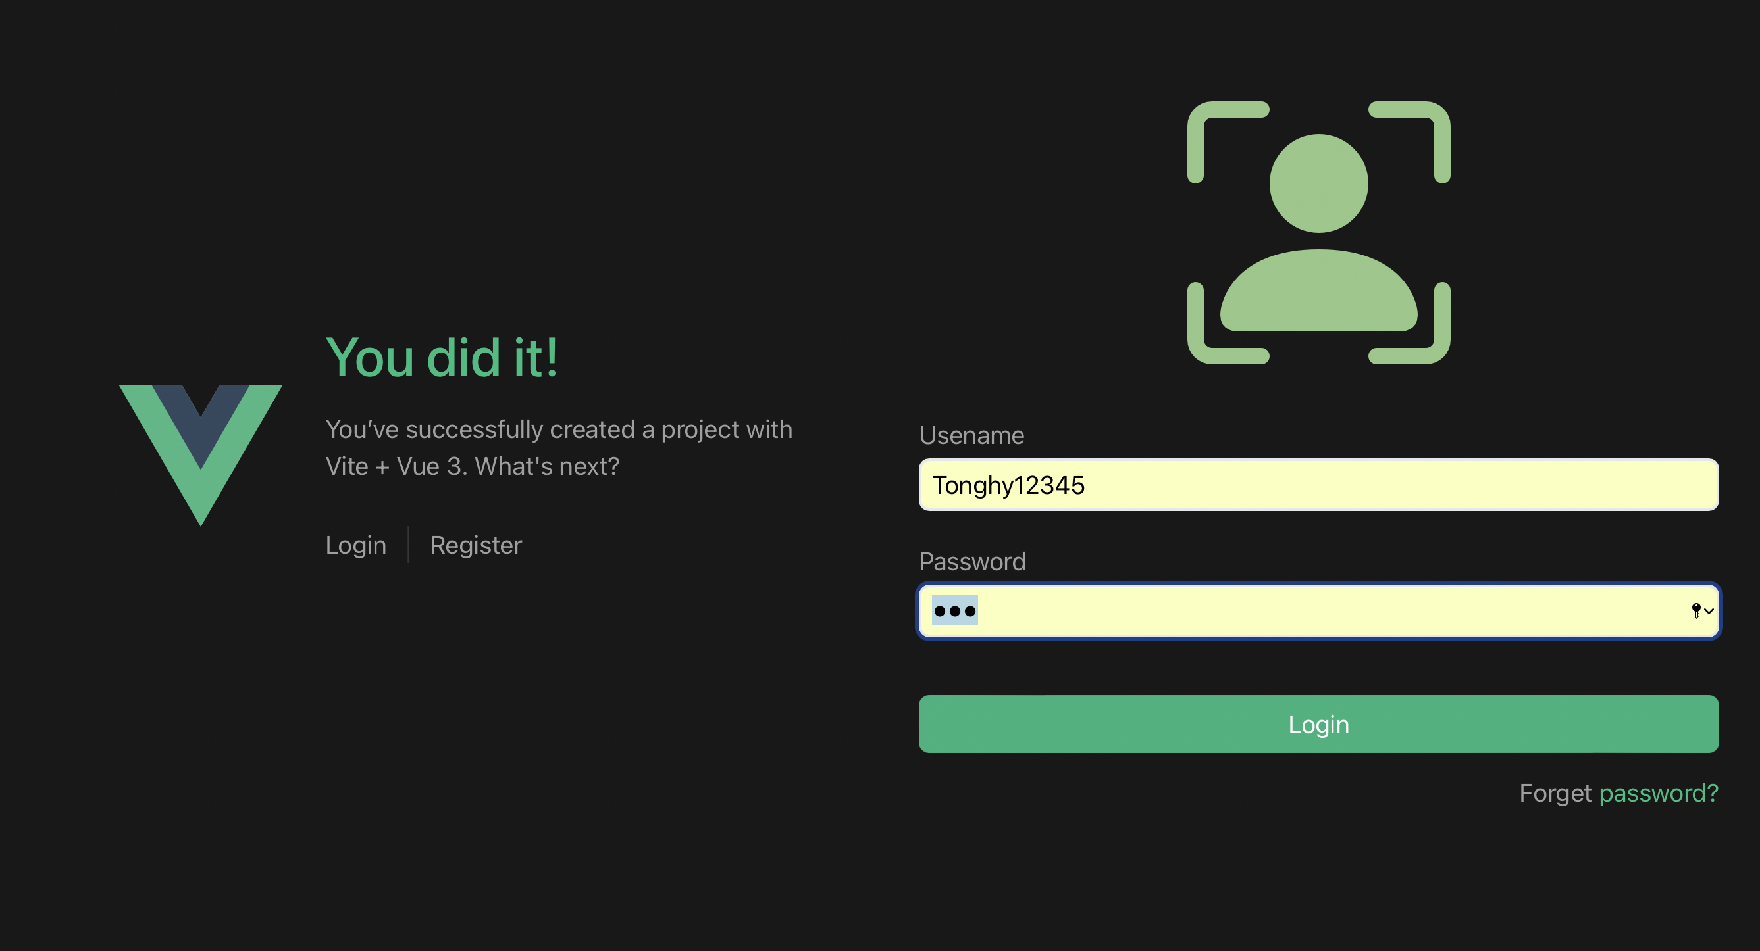

## Register account successfully



## Data in MongoDB after register it’s load new data in database.

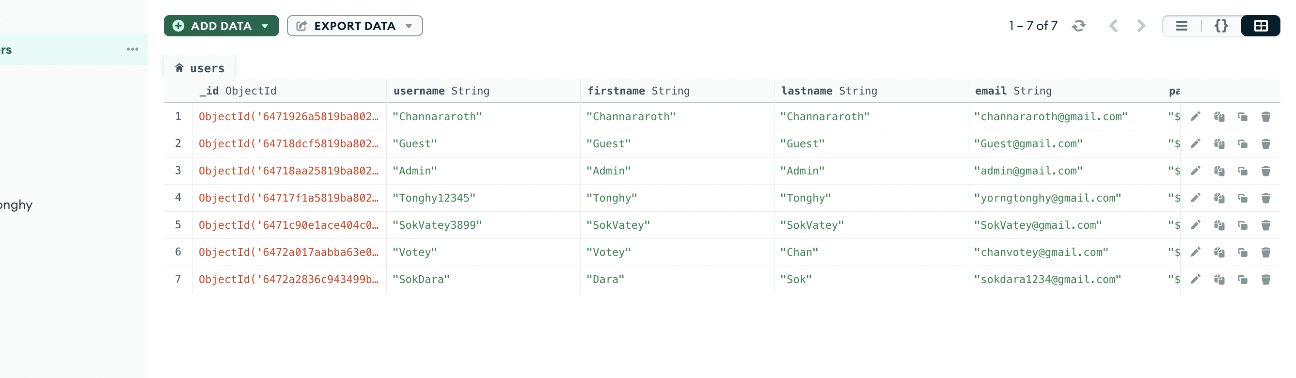

## Home-Page



# Exercise2: Continue implementing the authentication and user APIs

## Result of Ex02:

## login user and get token:

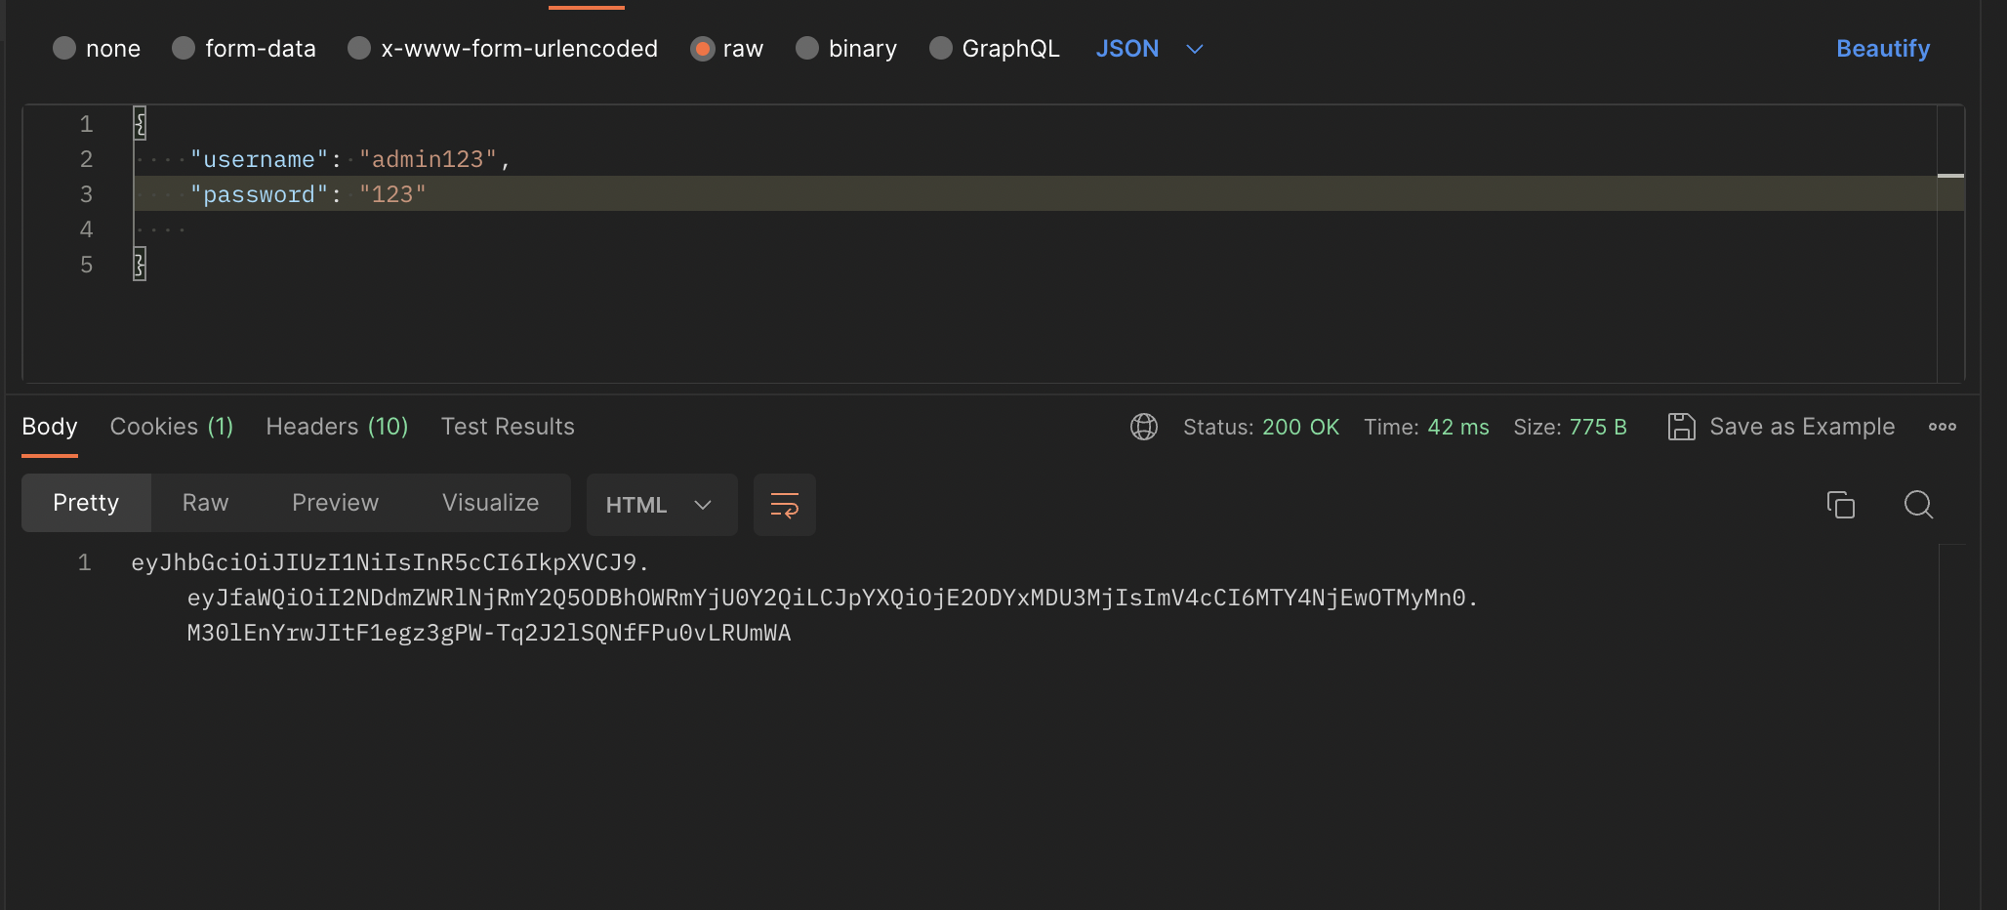

## Register

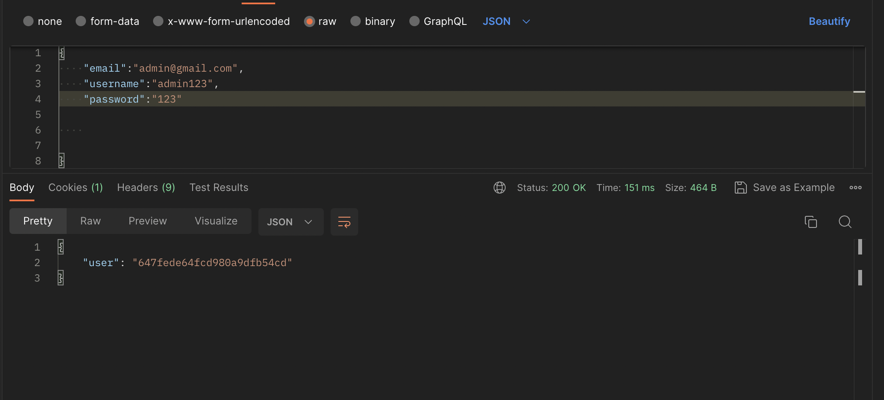

## Register already existed.

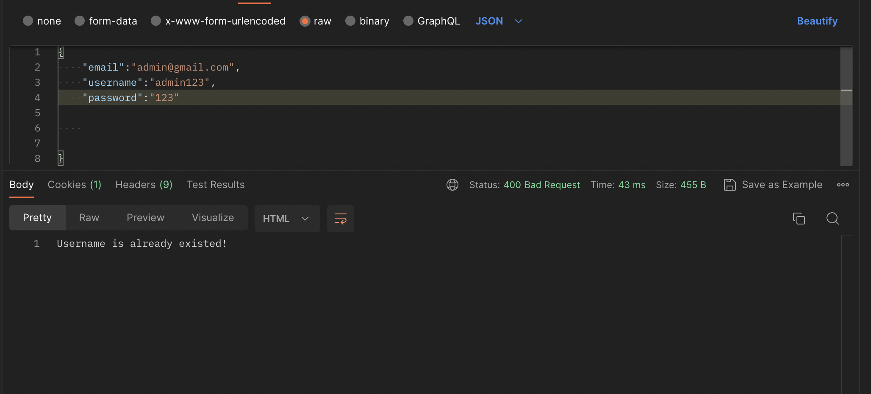

## When No Token

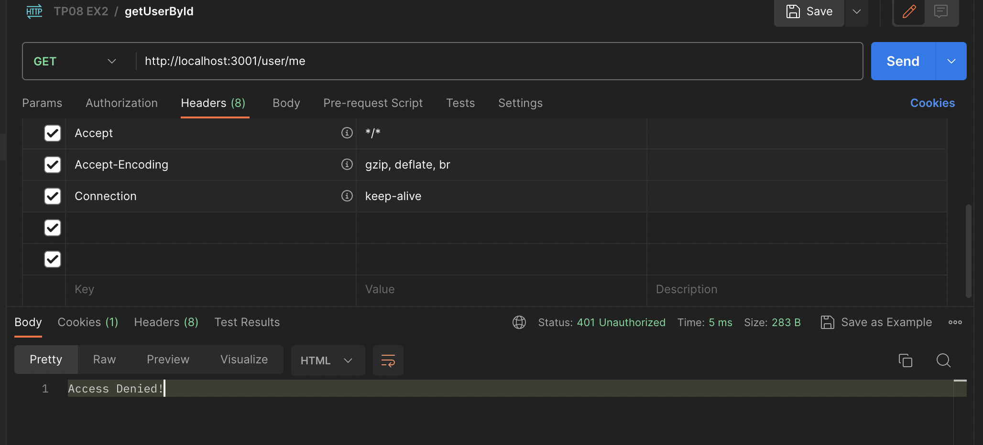

## Invalid Token

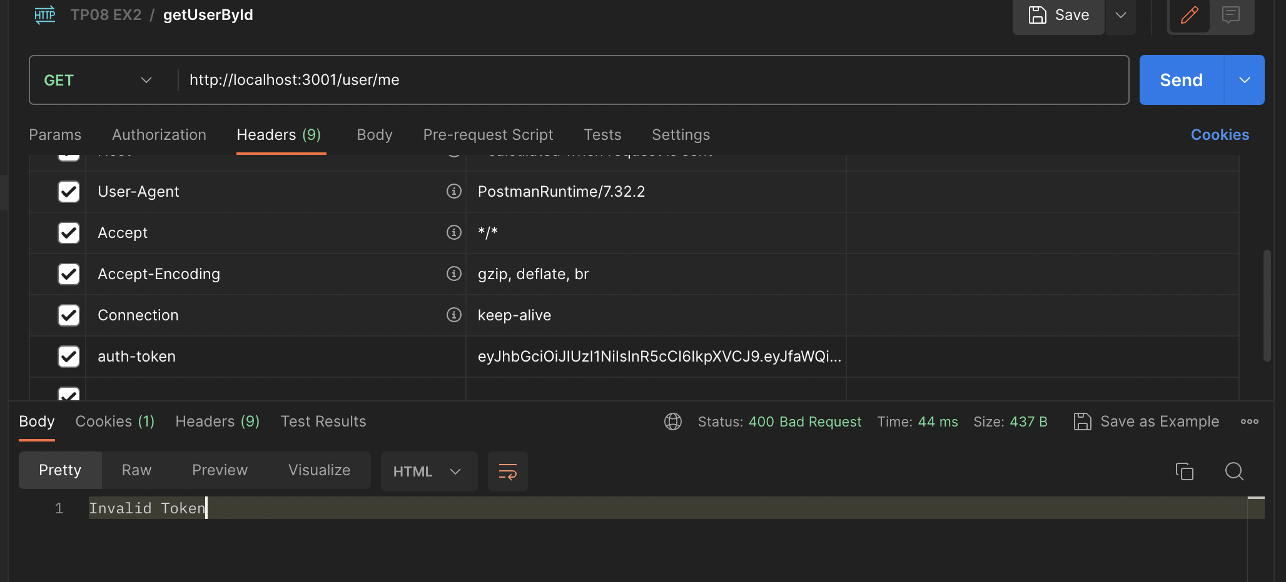

## Access by username via correct token

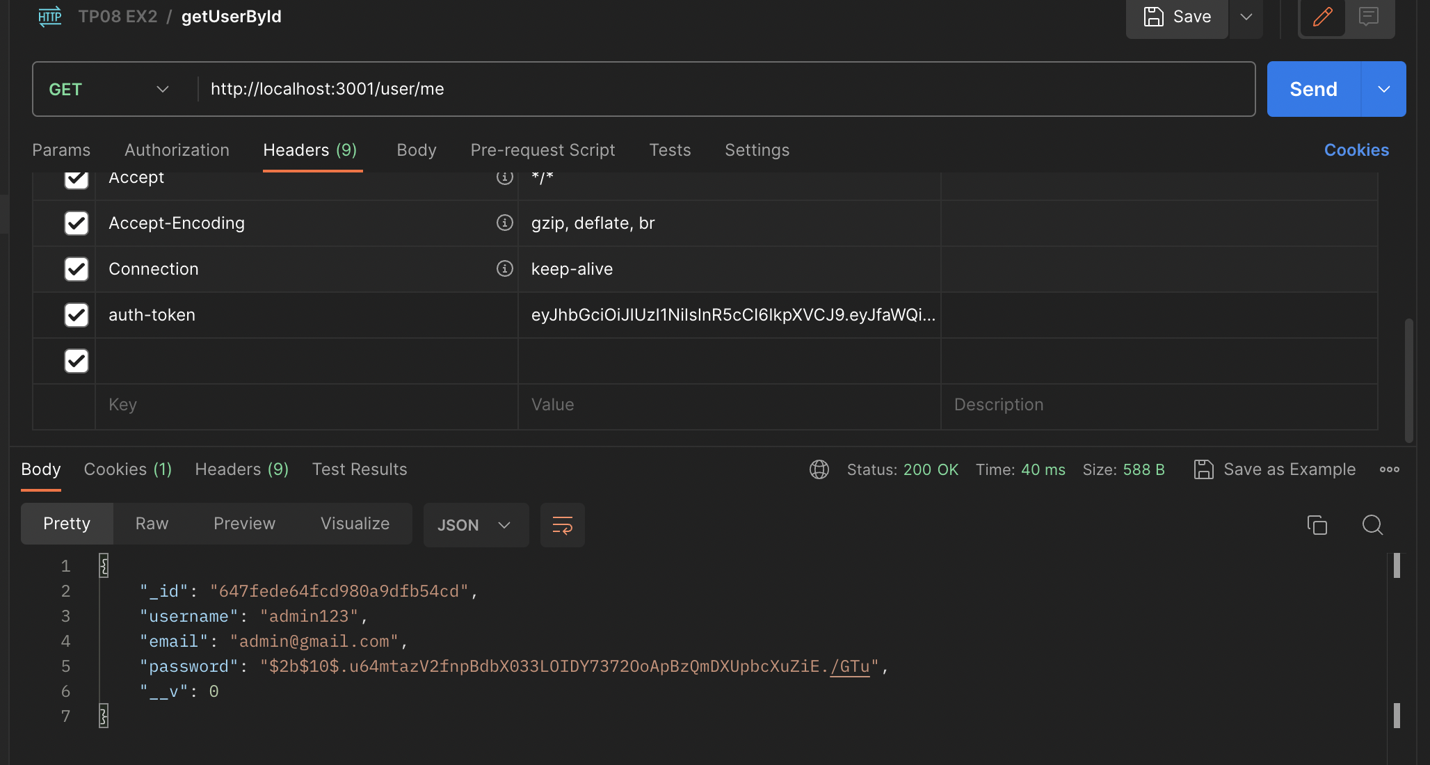

## When update user with invalid email format:

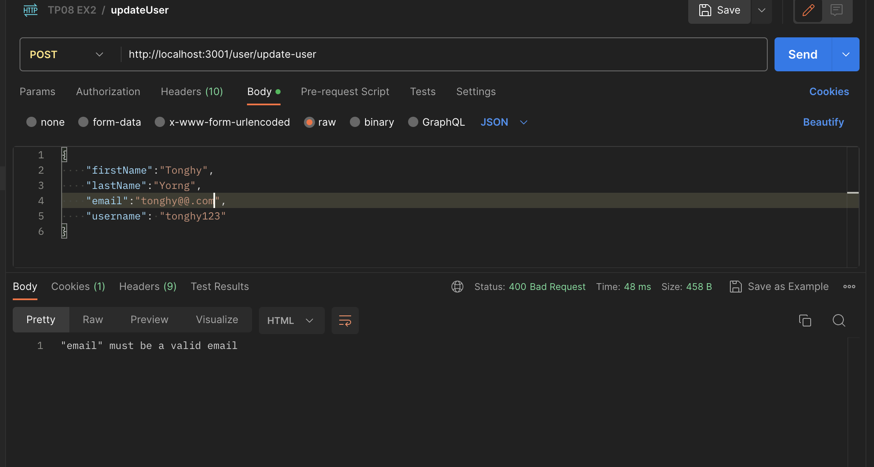

## Update user Successful:

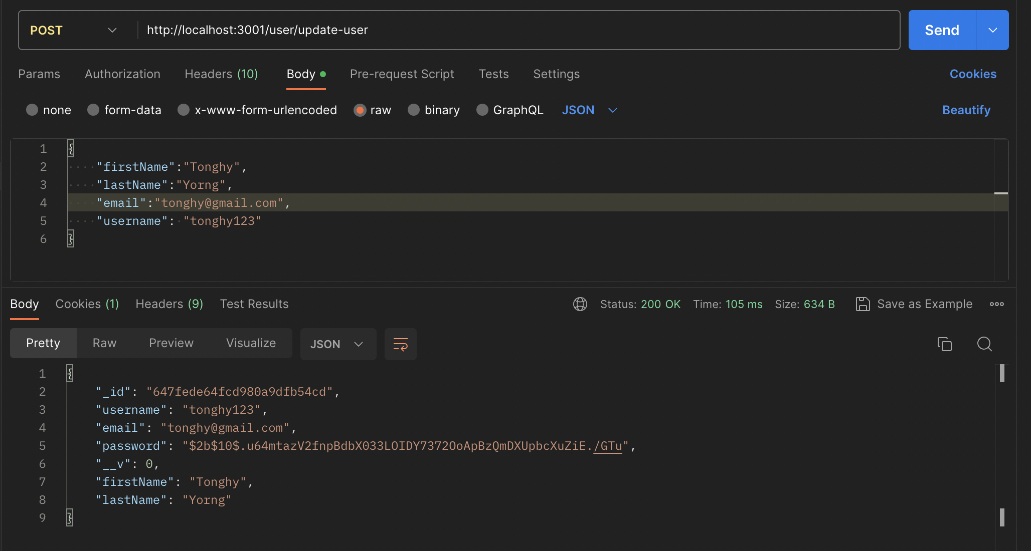

## When update password successfully:

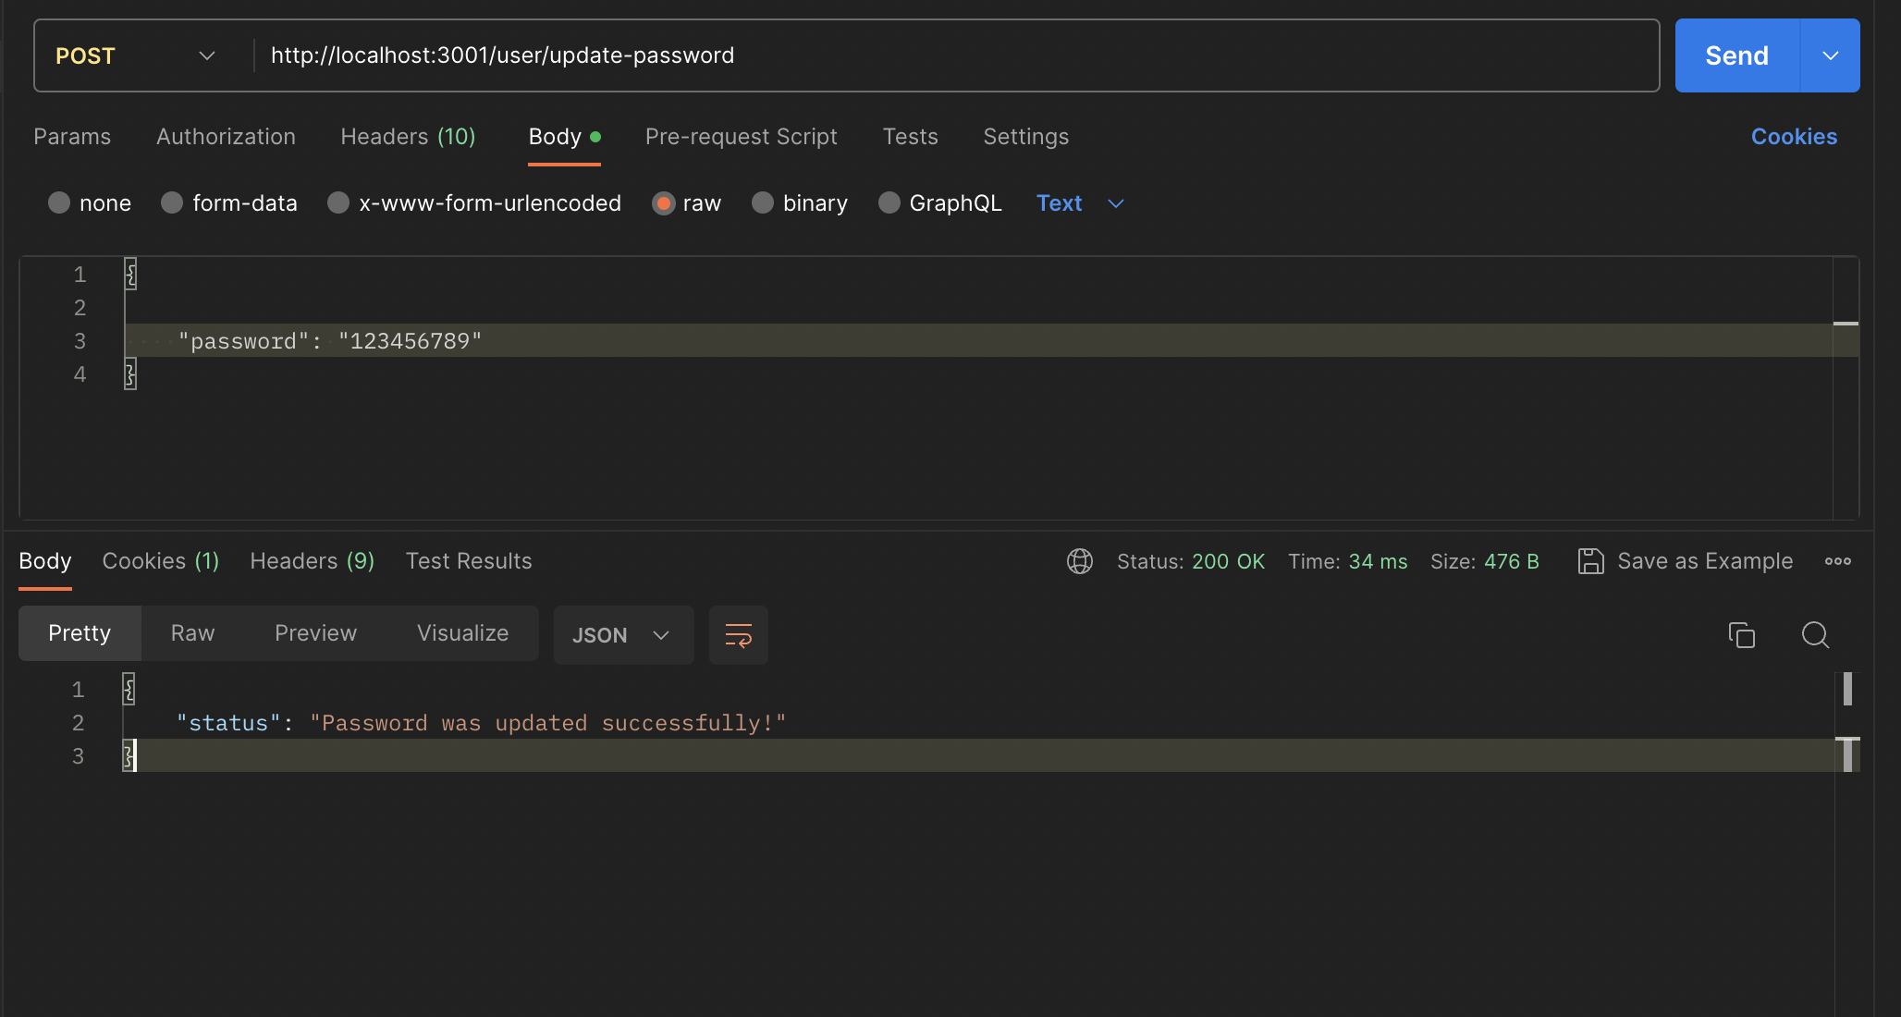

## Delete User

## Data before delete:

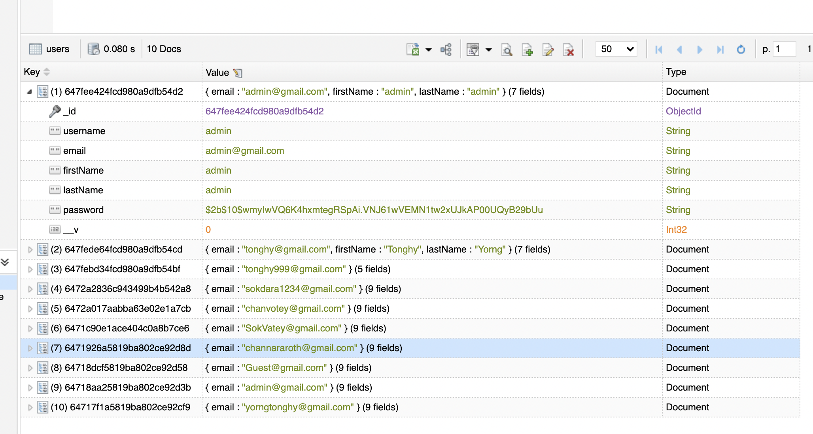

## When delete user does not exist in database.

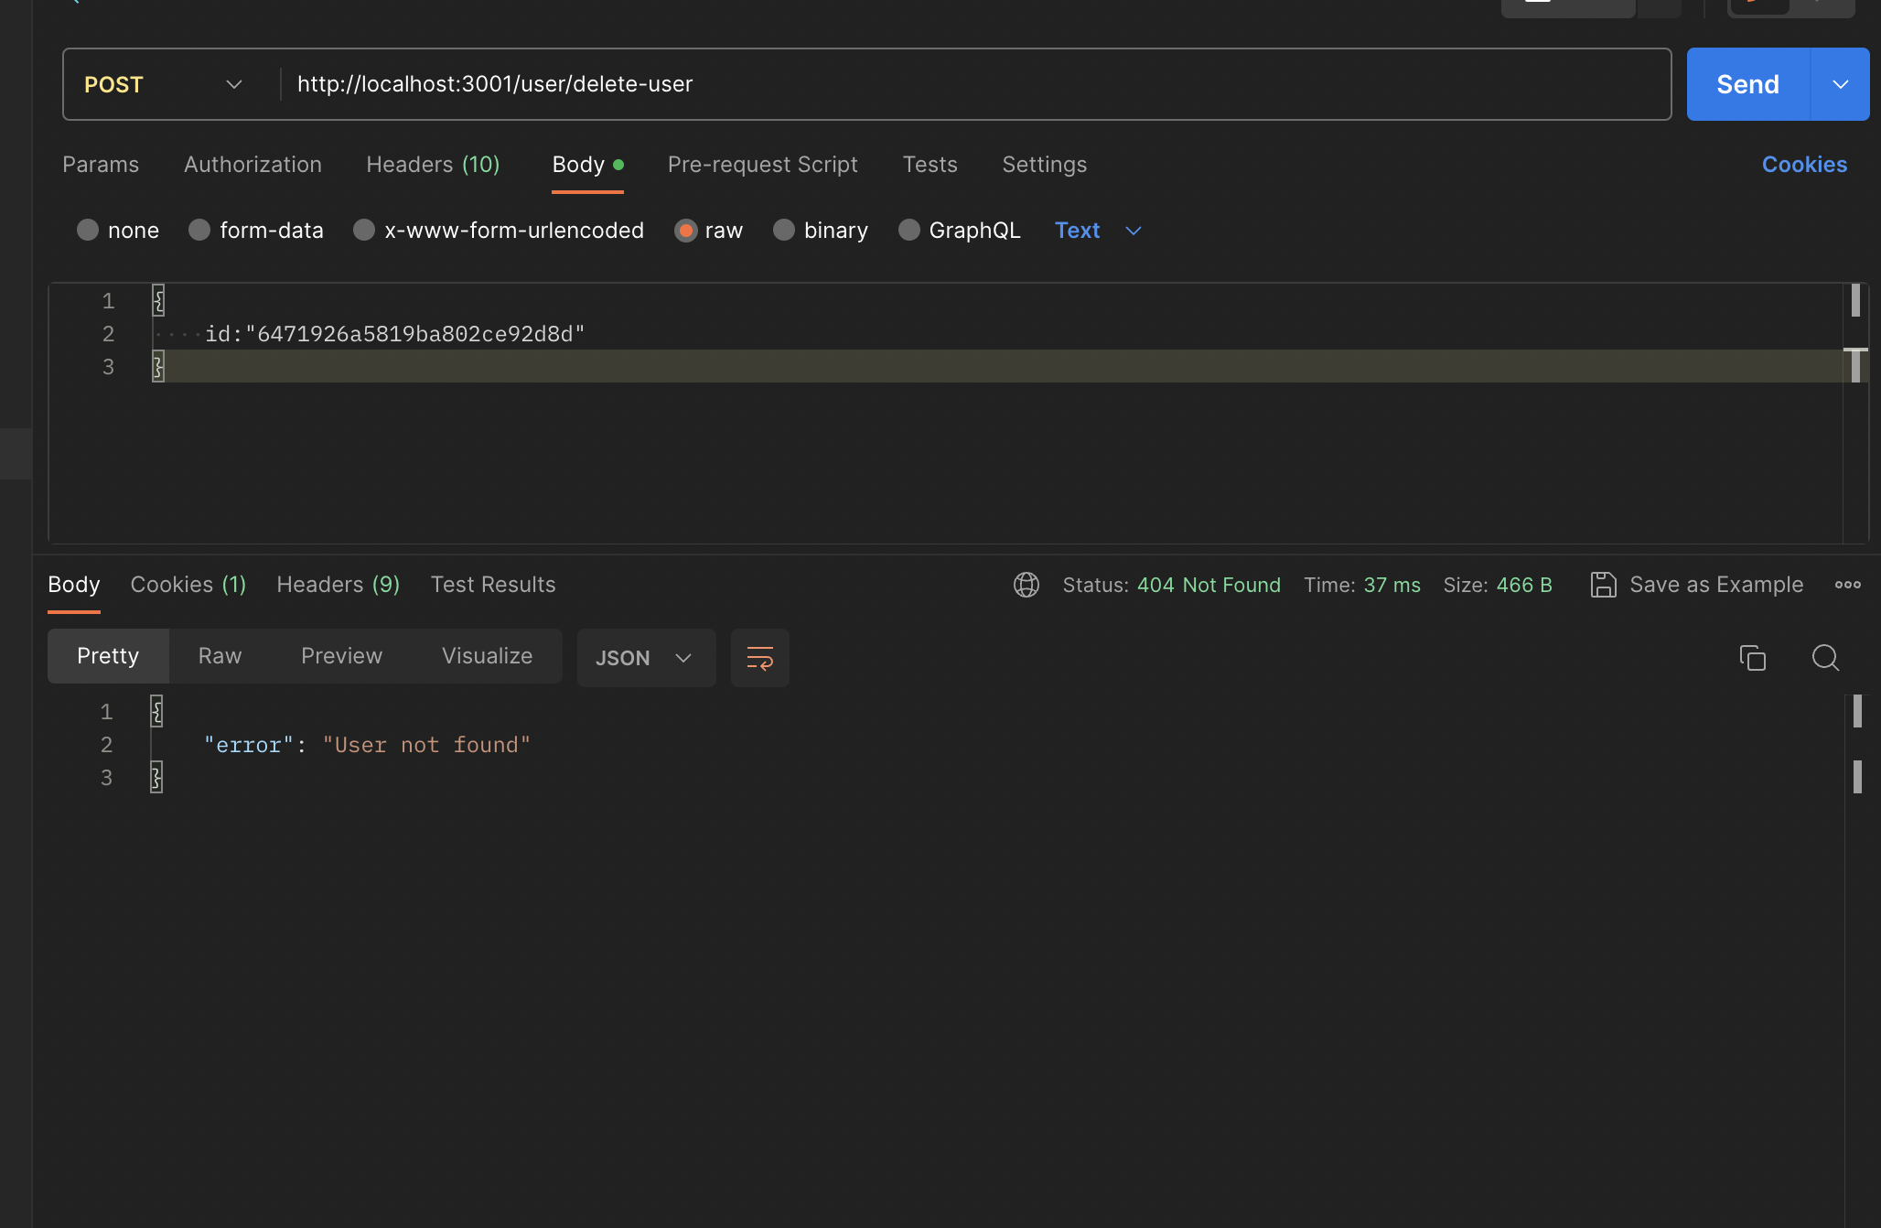

## Delete user successfully.

